Jumperton

# Project Overview

## High Concept and Mockup

You play as an android that must jump between platforms collecting all the coins they can while avoiding Obstacles and do so before the timer runs out to unlock their escape to the next level where they will rinse and repeat. Each level will get harder with more obstacles, more coins, etc.

”High concept mockup” screenshot

## Character

The player will control “Andy” the android. Andy is capable of running, jumping and double jumping. Andy is quite fragile and cannot withstand the impact of coming into contact with an obstacle.

## Camera

A third-person camera is centered to Andy, the camera can rotate around Andy to look at their surroundings, for any coins and obstacles. In cases where the camera would come into contact/go through a wall the camera would be pulled forward to sit against the wall, where it will return to its original distance when the camera has been moved away from the wall.

## Controls

Andy’s movement will be controlled with a keyboard using the WASD keys alongside the Spacebar for any jumps. The camera will be moved using the mouse, and the character will move in relation to the camera’s orientation.

# Game States

Each **section or phase** of your game, such as a main menu, a battle, overworld navigation, or credits screen, should be described below. Each section should be accompanied by a **UI wireframe**, indicating **what UI elements are needed** and **their positions** on the screen.

You will need at least the following: a **Splash Screen**, a **Main Menu**, and a **Gameplay** screen; sections for each are added below. If your game will have more, please add new sections for them.

## Splash Screen

****The game will start with 2 splash screens, the first being the Unreal Engine Splash Screen with the T3 Entertainment splash screen following.

## Main Menu

The main title will consist of 3 buttons, that being the Start, Settings, and Exit buttons. The main menu will also have the game title displayed on the top.

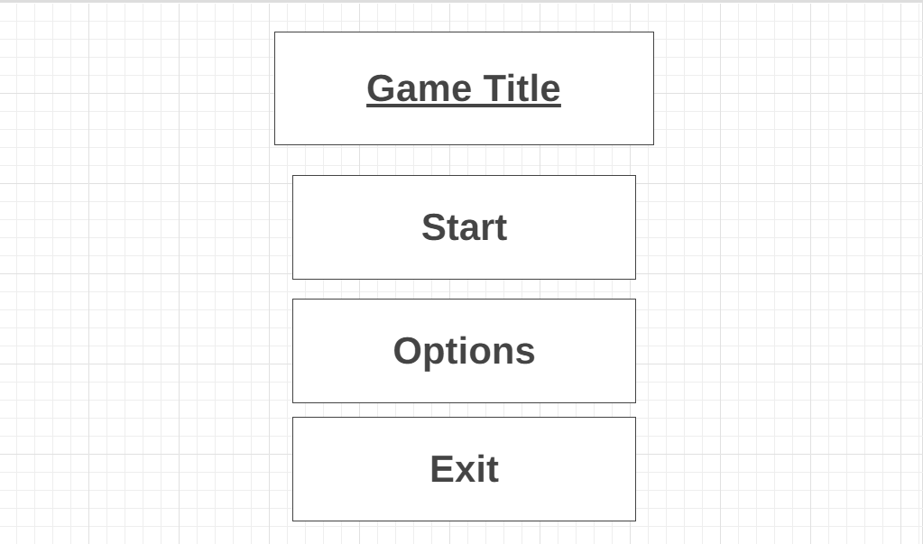

## Gameplay

While the game is active there will be a timer that counts down until the timer hits 0 where the level would end, in the remaining 10 seconds the text will turn red, and shake when counting down. In the top left corner there will be a coin counter to show the player how many of their coins they have picked up allowing them to see if they have missed any and when the door will open. In the middle bottom , there will be an image that will clearly display when the player is able to attempt a double jump, and will turn transparent and lighten when the player is unable to double jump.

# Roadmap

Provide an **overview** of the time taken to create this project and **the objectives that will be completed** by each section of time. (This doesn’t need to be super detailed – bullet points and lists will do fine)

|  |  |
| --- | --- |
| **Week** | **Objectives** |
| 1 | Gameplay   * Coin pickup * Timer * Door unlock * Obstacles   UI   * Coin UI * Timer UI * Double jump UI |
| 2 | Gameplay   * Level Layout * Main Menu Functionality   UI   * Main Menu * Splash Screen |

# Credits

Dominic Sarbu – Lead Developer

## Third-Party Works

If you are using any assets or plugins, please list them below.